**CSCI 1411: Fundamentals of Computing**

**Lab 4**

**Due Date: February 23, 2022**

**Name: Abhi Shrestha**

**Goals:**

* Use of graphics package
* Drawing simple graphical objects
* Use and understanding of simple objects

**Development Environment:** IDLE

**Skills:** importing packages, proper use of objects, simple graphics

**Deliverables:**

1. This lab handout with 6 screen shots (2 for part I and 4 for part II).
2. Your Python code for Part I of this lab. Name the file using the following format:  
   YourlastnameFirstnameLab04a.py

Example: If your name is Jamal Jones then you will name the file as follows:  
JonesJamalLab04a.py

1. Your Python code for Part II of this lab. Name the file using the following format:  
   YourlastnameFirstnameLab04b.py  
   Example: If your name is Jamal Jones then you will name the file as follows:  
   JonesJamalLab04b.py

How to take a **screen shot**:

* For a Windows 10: Use Snipping Tool to copy and CTRL + V to paste screen shot.
* For Mac: Shift + Command + 4 to copy and CTRL + V to paste screen shot.

**Part I – Skills Practice (10 points)**

* In this part of the lab, we will be modifying some existing code that uses the graphics package.
* Start IDLE.
* Click on File->New File. This will create a new window where we can start writing your code.
* Remember everything that is not a comment is case sensitive, meaning that upper- and lower-case matters!
* Type in the following code (typing it in helps you learn!)[1]

# File OgleDaveLab04a.py

# this is the first part of lab4. we will be drawing some simple

# objects using the graphics package. In this program the user will be prompted

# for several key object characteristics like size, shape, color, etc

# tell python we want to use the graphics package and all the things in it

# this package should be given to you by your instructor, and it must reside in the same

# directory as your code.

from graphics import *

#time is another package we will use, it is a system package, so python will find it

import time

# define the main routine

def main():

### Draw a colored circle at a point specified by the use

### first ask the user the name for the window

winName = input ("What would you like the name of the window to be? ")

### now ask for a color. Note, only certain colors are valid (blue, green, yellow, red, etc)

color1 = input ("What color would you like the circle to be? ")

### now ask for the center coordinates of the circle. Recall that ‘eval’ will take the input and

### convert it to numbers. NOTE: the comma is important here! The input should

### be something like 10,3

x1, y1 = eval (input ("what are the x, y coordinates of the center of circle? "))

### now ask for the radius of the circle

radius1 = eval(input("what is the radius of the circle? "))

### we now have all the input, so can create the window object, the center of the 1st circle

### and draw it

win = GraphWin(winName, 500, 500)

center1 = Point (x1, y1)

circ1 = Circle(center1, radius1)

circ1.setFill (color1)

circ1.draw (win)

### next, we ask for the same information about the second circle, and draw it

### note how similar this is to the code above. We are creating a second circle here

color2 = input ("What color would you like the second circle to be? ")

x2, y2 = eval (input ("what are the x, y coordinates of the center of circle? "))

radius2 = eval(input("what is the radius of the circle? "))

center2 = Point (x2, y2)

circ2 = Circle(center2, radius2)

circ2.setFill (color2)

circ2.draw (win)

### we have 2 circles, the next thing to do is to draw a line between the centers of them

### recall that center1 is the center of the 1st circle, and center2 is the center of the 2nd

line = Line(center1, center2)

### set the color of the line to be red

line.setFill('red')

### draw the line

line.draw(win)

### this statement has the computer wait for a mouse click from the user.

### on some systems this may only work with a left or a right mouse click

win.getMouse()

### this loop will now move the circle

for i in range (10):

### we arbitrarily chose to move the circle 10 points in the x&y directions

circ1.move(10,10)

### this gets rid of the line…it doesn’t have to be in the loop!

line.undraw()

### tell the computer to pause so that we can see the circle moving

time.sleep(2)

### once we are done with the movement, query the center of the moved circle

newCenter = circ1.getCenter()

### draw a new line from the center of the first cicle to the center of the new circle.

line = Line(circ1.getCenter(), center2)

line.setFill('red')

line.draw(win)

* Click on Run->Run Module
* Choose the following values:

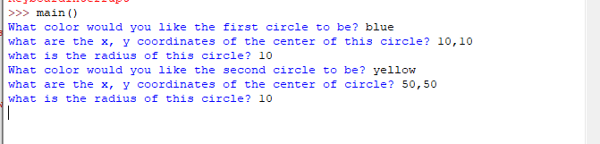

* Click the mouse button to start the circles moving
* Take a screen shot before the program starts to move the circle and insert it below

* Take a screen shot after the circle moves to the final location

* Select File->Close to close this module.

**Part II – Moving a circle around another circle. (15 pts)**

* Now you are going to apply what you have learned in Part I of this lab. Feel free to refer to Part I if you need help with starting a new project, naming your file, running it, etc.
* You will turn in 4 screen shots (see below) embedded below in this document and your python code
* The goal in this lab is to:
  + Create a file called LastnameFirstnameLab04b.py
  + Create a graphWin of size (500,500)
  + Title the graphWin “Lab 4 - LastnameFirstname” so if your name is Rajiv Ramnath, your window would be titled “Lab 4 – RamnathRajiv"
  + Inside the window you will draw a circle. Just as in Part I, prompt the user for the color of the window, the center coordinates (x1, y1), and the radius (r1).
  + Draw the circle.
  + Once the first circle is drawn, you will create a second circle with the following properties:
    - The radius for the second circle is ½ the radius of the first circle. (r2= ½ * r1)
    - The color of the second circle is ‘green’.
    - The distance from the center of the first circle to the center of the second circle is twice the radius of the first circle.
    - The initial position of the second circle is 90 degrees above the first circle (HINT: the center point for circle 2 is x2=x1, y2 = y1-(2*r1))
  + Draw the second circle.
  + Now draw a red line between the centers of the 2 circles.
  + Once this is drawn, we are almost done.
  + The final part of the program is to move the second circle around the first circle every time the user clicks the mouse. On each click, the second circle moves 90 degrees to the right, etc. (HINT: draw it out on paper, and write down the x2, y2 coordinates each time the circle moves.) The sequence should look something like this:
* 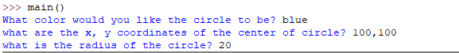

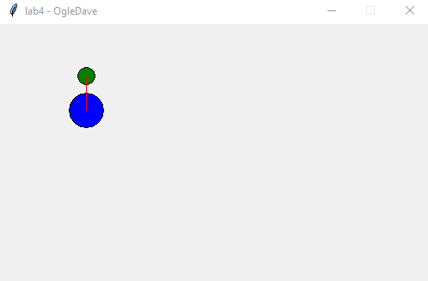

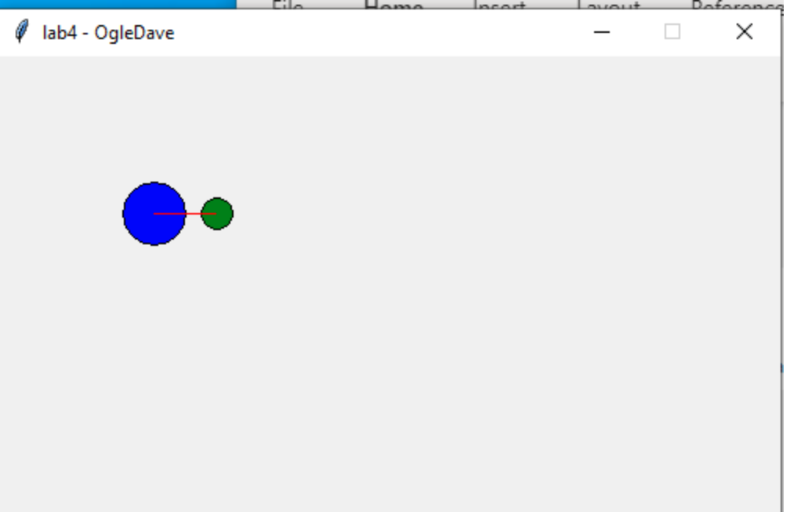

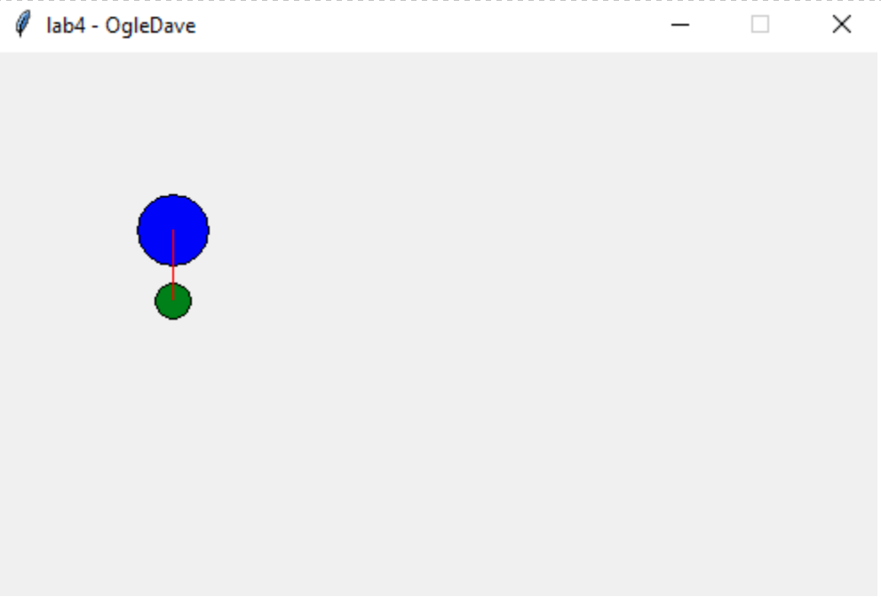

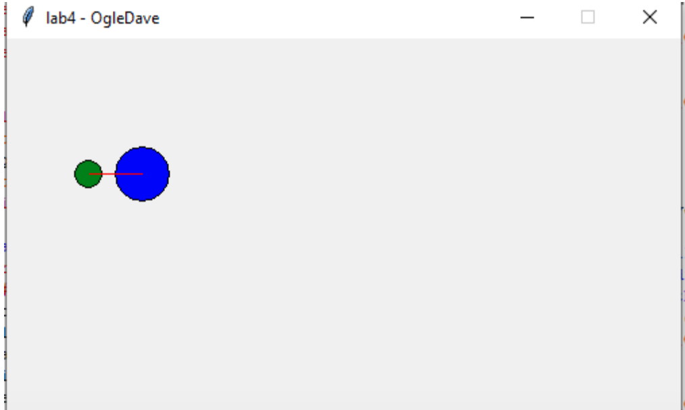

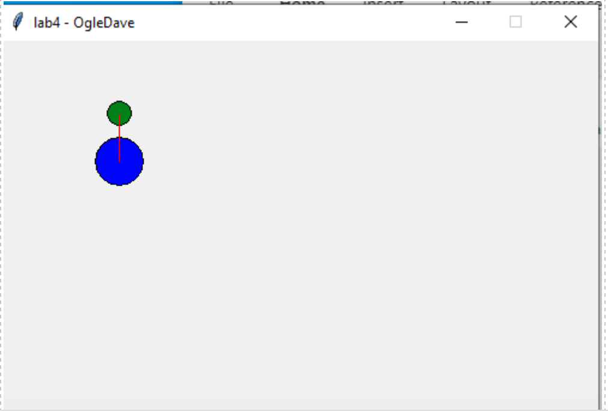

INSERT your screenshots here:

1. Make sure that you save the python file and graphics.py file in the same folder.